NAMA: FADHIL PRAWIRA

NIM : 21060120140057

MATA KULIAH : Pemrograman berorientasi objek

Tugas 1 PBO reguler dari diagram (<https://pastebin.com/raw/23zU2kge> )

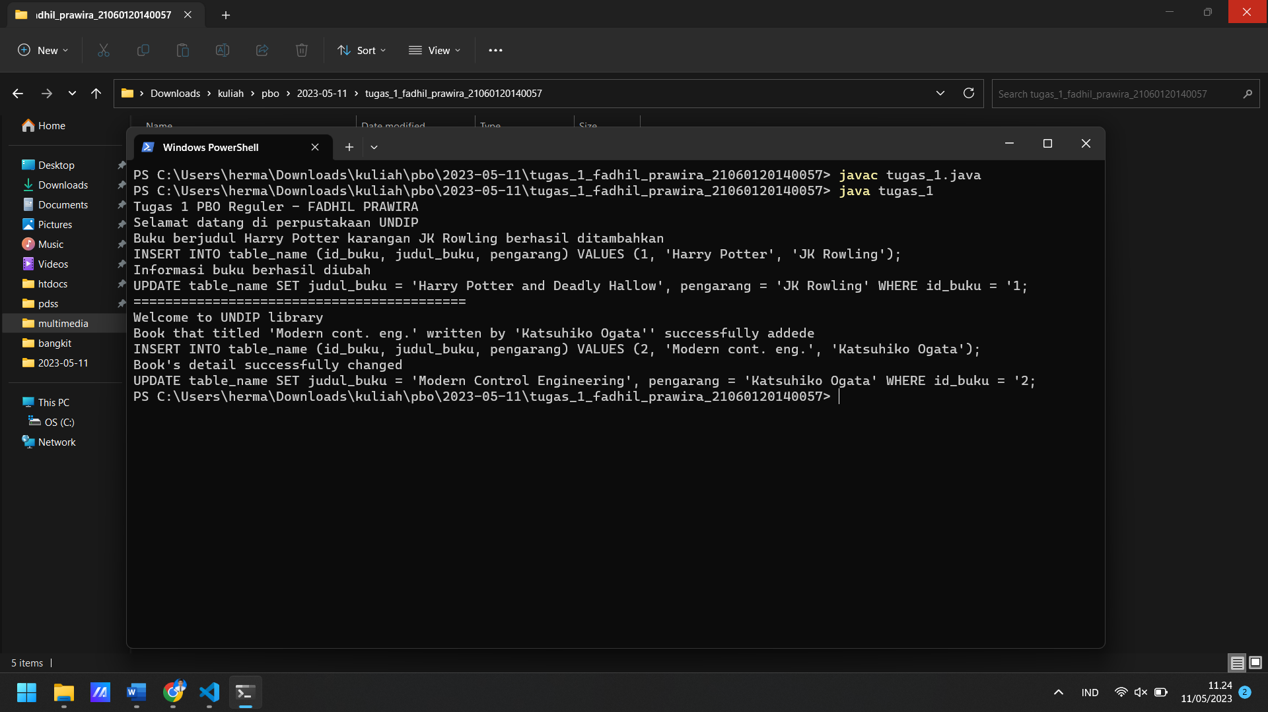

|  |
| --- |
| // Tugas 1 PBO Reguler  // FADHIL PRAWIRA  // 21060120140057  class Buku {  int id_buku;  String id_buku_str;  String judul_buku;  String pengarang;  public void insert_data(int id_buku, String judul_buku, String pengarang) {  id_buku_str = Integer.toString(id_buku);  // The body of insert_data() is provided here  System.out.println("Buku berjudul " + judul_buku + " karangan " + pengarang + " berhasil ditambahkan");  System.out.println("INSERT INTO table_name (id_buku, judul_buku, pengarang) VALUES (" + id_buku_str + ", '"+ judul_buku + "', '"+ pengarang +"');");  }  public void update_data(int id_buku, String judul_buku, String pengarang) {  id_buku_str = Integer.toString(id_buku);  // The body of update_data() is provided here  System.out.println("Informasi buku berhasil diubah");  System.out.println("UPDATE table_name SET judul_buku = '" + judul_buku + "', pengarang = '" + pengarang + "' WHERE id_buku = '" + id_buku_str + ";");  }  }  class Buku_lokal extends Buku {  // ini fungsi lokal  public void ucapan() {  System.out.println("Selamat datang di perpustakaan UNDIP");  }  }  class Buku_asing extends Buku {  // ini fungsi lokal  public void greeting() {  System.out.println("Welcome to UNDIP library");  }  public void insert_data(int id_buku, String judul_buku, String pengarang) {  id_buku_str = Integer.toString(id_buku);  // The body of insert_data() is provided here  System.out.println("Book that titled '" + judul_buku + "' written by '" + pengarang + "'' successfully addede");  System.out.println("INSERT INTO table_name (id_buku, judul_buku, pengarang) VALUES (" + id_buku_str + ", '"+ judul_buku + "', '"+ pengarang +"');");  }  public void update_data(int id_buku, String judul_buku, String pengarang) {  id_buku_str = Integer.toString(id_buku);  // The body of update_data() is provided here  System.out.println("Book's detail successfully changed");  System.out.println("UPDATE table_name SET judul_buku = '" + judul_buku + "', pengarang = '" + pengarang + "' WHERE id_buku = '" + id_buku_str + ";");  }  }  class tugas_1 {  public static void main(String[] args) {  System.out.println("Tugas 1 PBO Reguler - FADHIL PRAWIRA");  Buku_lokal myLocalBook = new Buku_lokal(); // Create a Buku_lokal object  myLocalBook.ucapan();  myLocalBook.insert_data(1, "Harry Potter", "JK Rowling");  myLocalBook.update_data(1, "Harry Potter and Deadly Hallow", "JK Rowling");  System.out.println("==========================================");  Buku_asing myForeignBook = new Buku_asing(); // Create a Buku_asing object  myForeignBook.greeting();  myForeignBook.insert_data(2, "Modern cont. eng.", "Katsuhiko Ogata");  myForeignBook.update_data(2, "Modern Control Engineering", "Katsuhiko Ogata");  }  } |